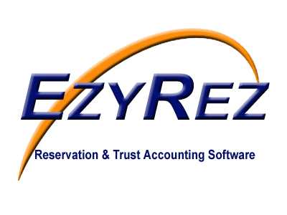



Direct Debit Authorisation Form

I authorise REI Master Pty. Ltd. ATF Windowen Unit Trust T/As EzyRez / REI Master to directly debit my bank account using my bank account details on file for the following goods or services. I understand there will be a $11.00 fee charged if the processing of this amount is rejected because of insufficient funds.

Customer Number: ________________________________________

Detail(s) Number of Attendees

AFAR Compliance Seminar @ $88/attendee _____________

Venue (Please Circle)
GOLD COAST 15th Feb 2018
WEBINAR 22nd February 2018

Total to Charge Bank Account @ $88/attendee $
_________________________________________________________________

TO BE COMPLETED BY AUTHORISED BANK SIGNATORY ONLY

Signed: _____________________________________ Date / /2018

Name (Printed): _____________________________________________________

Position: _______________________________________________________

Business: _______________________________________________________

